How fair was medieval crime and punishment?
Task 1: Write answers to these questions around the source.
- Why do you think this is happening? (E.g. what have they done wrong?)

- List what you can see (e.g. a dog)

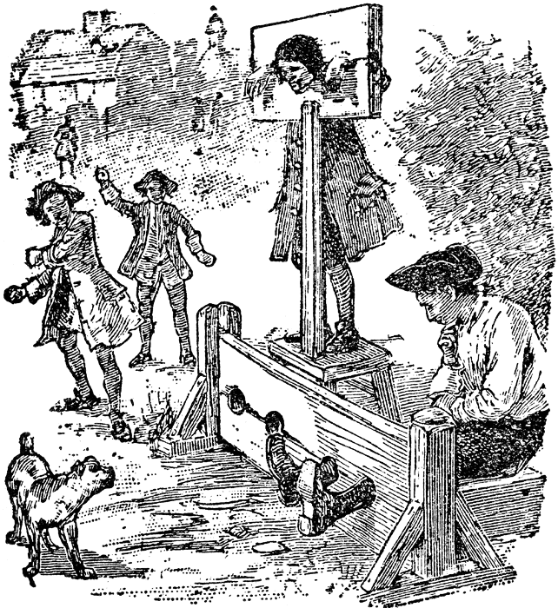
- What do you think is happening in this source?

- Is this a fair punishment?

- What does this source tell you about crime and punishment in medieval times?

- Any questions you want to ask?

Task 2: Answer these questions

- How useful is the source above in teaching people about punishments in the medieval times?

- What is a ‘vigilante’?

- Why do you think this time period was full of vigilantes?

